**Lab Exercise 19- ESP32 Http Wi-Fi using Blynk Web and Mobile App for Two Servo Motor**

In this lab exercise, you will control a **Servo Motor** connected to an **ESP32** using **Blynk** and the **Wokwi** simulator. The ESP32 will communicate with the **Blynk cloud** over Wi-Fi, allowing you to control the Servo motor's angle through the **Blynk app** on your smartphone.

**Objective**

To control a Servo motor connected to the ESP32 through the **Blynk** app using **Wi-Fi** in the **Wokwi** simulator.

**Materials Required**

* ESP32 Development Board (in Wokwi)
* Servo Motor (in Wokwi)
* Wokwi Account (<https://wokwi.com/>)
* Blynk App installed on your smartphone (available on Google Play or the App Store)
* Arduino IDE or Wokwi's built-in editor
* Blynk Auth Token (from the Blynk app)

**Steps to Set Up the Lab**

**1. Set Up the Circuit in Wokwi**

1. Visit [**https://wokwi.com/**](https://wokwi.com/) and create a new project.
2. Add an **ESP32** and a **Servo Motor** in the simulation environment.
   * In Wokwi, you can add a **Servo motor** by clicking on "Add a part" and searching for **Servo**.
   * **Connect the Servo Motor**:
     + **VCC** pin of the Servo to **3.3V** pin of ESP32.
     + **GND** pin of the Servo to **GND** pin of ESP32.
     + **Control Signal** pin of the Servo to **GPIO 2** (or any other available GPIO pin).

**Circuit Diagram in Wokwi**

ESP32 3.3V -> VCC of Servo

ESP32 GND -> GND of Servo

ESP32 GPIO 2 -> Signal pin of Servo

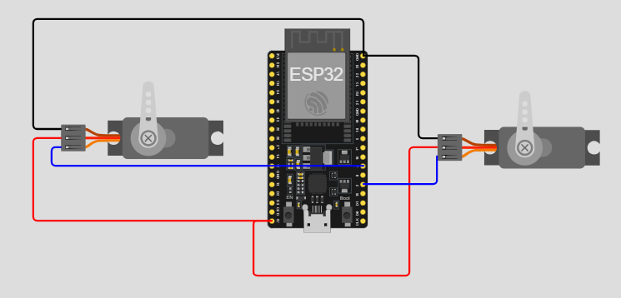

**2. Set Up the Blynk App**

1. Download and install the **Blynk app** from the **Google Play Store** or **Apple App Store**.
2. **Create a New Project** in the Blynk app:
   * Select **ESP32** as the device.
   * Choose **Wi-Fi** as the connection type.
   * You'll receive an **Auth Token** via email. Copy this token for use in the code.
3. **Add a Slider Widget** to the Blynk app:
   * Click on the "+" icon to add a widget.
   * Add a **Slider** widget.
   * Set the slider's **output pin** to **V1** (Virtual Pin 1).
   * Set the slider range from **0** to **180** (for Servo motor angle control).

**3. Write the ESP32 Code in Wokwi**

1. In Wokwi, use the following code to control the Servo motor using Blynk.

Servo servo1;

Servo servo2;

void setup()

{

Serial.begin(115200);

Blynk.begin(auth, ssid, pass);

servo1.attach(2); // Attach servo 1 to GPIO 2

servo2.attach(4); // Attach servo 2 to GPIO 4

}

void loop()

{

Blynk.run();

}

BLYNK_WRITE(V0) // Slider Widget for Servo 1 on V0

{

int pos1 = param.asInt(); // Get value from slider

servo1.write(pos1); // Set servo 1 position

Blynk.virtualWrite(V2, pos1);

}

BLYNK_WRITE(V1) // Slider Widget for Servo 2 on V1

{

int pos2 = param.asInt(); // Get value from slider

servo2.write(pos2); // Set servo 2 position

Blynk.virtualWrite(V3, pos2);

}

**4. Simulate and Run the Project in Wokwi**

1. **Run the simulation** by clicking the green "Play" button in Wokwi.
2. The ESP32 will connect to the **Wokwi-GUEST** Wi-Fi network.
3. Open the **Serial Monitor** in Wokwi to see the ESP32 connecting to Wi-Fi and Blynk.

**5. Control the Servo with the Blynk App**

1. Open the **Blynk app** on your smartphone.
2. Use the **Slider** in the Blynk app to control the Servo motor's angle. The range is from **0 to 180 degrees**, and you can slide the control to move the Servo to different angles.

**Explanation of the Code**

1. **Blynk Setup**:
   * The **Blynk Auth Token** is used to authenticate your ESP32 with the Blynk cloud.
   * The ESP32 connects to the **Wokwi-GUEST** Wi-Fi network (no password required).
2. **Servo Motor Control**:
   * The **Servo** is attached to **GPIO 2** using the **Servo library**.
   * The **BLYNK_WRITE(V1)** function listens for changes on **Virtual Pin 1 (V1)**, which is linked to the Slider in the Blynk app.
   * When the slider is moved, the Servo motor will adjust its position according to the value received (0 to 180).
3. **Serial Monitor**:
   * The Serial Monitor prints the current angle of the Servo motor, helping to debug and visualize the Servo's movement.

**Additional Features**

You can expand this project by:

* Adding more Servo motors and controlling them through different Virtual Pins (e.g., V2, V3).
* Using other widgets like buttons or gauges in the Blynk app to create a more complex control system.
* Adding sensors and sending real-time data to the Blynk app for monitoring.

**Conclusion**

In this lab exercise, you've learned how to control a Servo motor connected to an ESP32 using **Blynk** and **Wokwi**. By using the Blynk app, you can easily adjust the Servo motor's angle from your smartphone. This project is a good foundation for creating more complex IoT systems where you can control multiple actuators and monitor sensor data remotely.